**SPRING CORE AND MAVEN**

* **Exercise 1: Configuring a Basic Spring Application**

🡺 solution:

Dependencies in pom.xml

<dependency>

<groupId>org.springframework</groupId>

<artifactId>spring-context</artifactId>

<version>5.3.22</version>

</dependency>

<dependency>

<groupId>org.springframework</groupId>

<artifactId>spring-core</artifactId>

<version>5.3.22</version>

</dependency>

applicationContext.xml

<?xml version="1.0" encoding="UTF-8"?>

<beans xmlns="http://www.springframework.org/schema/beans"

xmlns:xsi="http://www.w3.org/2001/XMLSchema-instance"

xsi:schemaLocation="http://www.springframework.org/schema/beans

http://www.springframework.org/schema/beans/spring-beans.xsd">

<bean id="bookRepository" class="com.shom.library.repository.BookRepository" />

<bean id="bookService" class="com.shom.library.service.BookService"/>

</beans>

BookRepository.java

package com.shom.library.repository;

public class BookRepository {

public void getBooks() {

System.out.println("Getting books--");

}

}

BookService.java

package com.shom.library.service;

public class BookService {

public void displayBooks() {

System.out.println("Showing books from book repository---");

}

}

Main.java

import org.springframework.context.ApplicationContext;

import org.springframework.context.support.ClassPathXmlApplicationContext;

import com.shom.library.repository.BookRepository;

import com.shom.library.service.BookService;

public class Main {

public static void main(String[] args) {

ApplicationContext context = new ClassPathXmlApplicationContext("applicationContext.xml");

BookRepository bookRepository = (BookRepository) context.getBean("bookRepository");

bookRepository.getBooks();

BookService bookService = (BookService) context.getBean("bookService");

bookService.displayBooks();

}

}

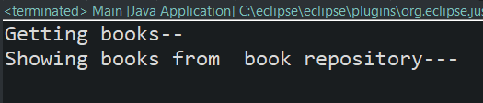

**Exercise 2: Implementing Dependency Injection**

**🡺solution:**

applicationContext.xml

<?xml version="1.0" encoding="UTF-8"?>

<beans xmlns="http://www.springframework.org/schema/beans"

xmlns:xsi="http://www.w3.org/2001/XMLSchema-instance"

xsi:schemaLocation="http://www.springframework.org/schema/beans

http://www.springframework.org/schema/beans/spring-beans.xsd">

<bean id="bookRepository" class="com.shom.library.repository.BookRepository" />

<bean id="bookService" class="com.shom.library.service.BookService">

<property name="bookRepository" ref="bookRepository"/>

</bean>

</beans>

BookRepository.java

package com.shom.library.repository;

public class BookRepository {

public void getBooks() {

System.out.println("Getting books--");

}

}

BookService.java

package com.shom.library.service;

import com.shom.library.repository.BookRepository;

public class BookService {

private BookRepository bookRepository;

public void setBookRepository(BookRepository bk) {

this.bookRepository = bk;

}

public void displayBooks() {

bookRepository.getBooks();

System.out.println("Showing books from book repository---");

}

}

Main.java

import org.springframework.context.ApplicationContext;

import org.springframework.context.support.ClassPathXmlApplicationContext;

import com.shom.library.service.BookService;

public class Main {

public static void main(String[] args) {

ApplicationContext context = new ClassPathXmlApplicationContext("applicationContext.xml");

BookService bookService = (BookService) context.getBean("bookService");

bookService.displayBooks();

}

}

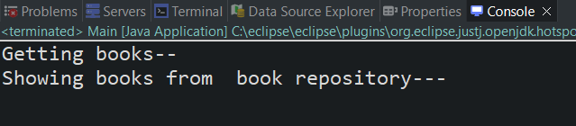

**Exercise 4: Creating and Configuring a Maven Project**

**🡺 solution**

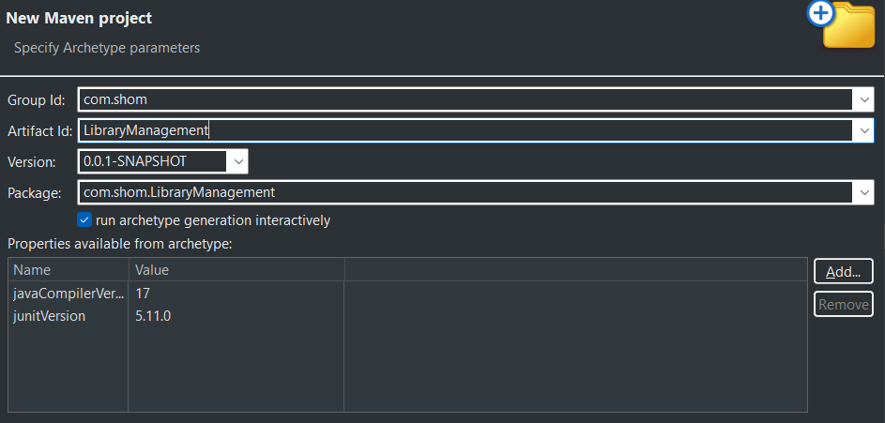

pom.xml

<project xmlns="http://maven.apache.org/POM/4.0.0" xmlns:xsi="http://www.w3.org/2001/XMLSchema-instance"

xsi:schemaLocation="http://maven.apache.org/POM/4.0.0 http://maven.apache.org/xsd/maven-4.0.0.xsd">

<modelVersion>4.0.0</modelVersion>

<groupId>com.shom</groupId>

<artifactId>LibraryManagement1</artifactId>

<version>0.0.1-SNAPSHOT</version>

<packaging>jar</packaging>

<name>LibraryManagement1</name>

<url>http://maven.apache.org</url>

<properties>

<project.build.sourceEncoding>UTF-8</project.build.sourceEncoding>

</properties>

<dependencies>

<dependency>

<groupId>junit</groupId>

<artifactId>junit</artifactId>

<version>3.8.1</version>

<scope>test</scope>

</dependency>

<dependency>

<groupId>org.springframework</groupId>

<artifactId>spring-context</artifactId>

<version>5.3.22</version>

</dependency>

<dependency>

<groupId>org.springframework</groupId>

<artifactId>spring-core</artifactId>

<version>5.3.22</version>

</dependency>

<dependency>

<groupId>org.springframework</groupId>

<artifactId>spring-aop</artifactId>

<version>5.3.22</version>

</dependency>

<dependency>

<groupId>org.springframework</groupId>

<artifactId>spring-webmvc</artifactId>

<version>5.3.22</version>

</dependency>

</dependencies>

<build>

<plugins>

<plugin>

<groupId>org.apache.maven.plugins</groupId>

<artifactId>maven-compiler-plugin</artifactId>

<version>3.8.1</version>

<configuration>

<source>1.8</source>

<target>1.8</target>

</configuration>

</plugin>

</plugins>

</build>

</project>